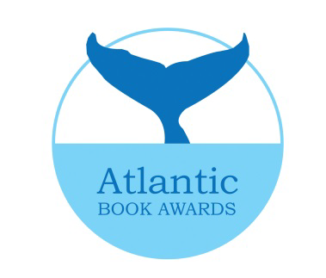
The Senator Don Oliver Young Black Voices Book Prize
Submission Form

Title: ___________________________________________________________

Author: _________________________________________________________

Author Contact Information:

Address: _______________________________________________________

Telephone: ______________________ E-mail: ________________________

Author Date of Birth: _______________________

Publisher: ______________________________________________________

Publisher Contact: ______________________________________________

Address: ________________________________________________________

Telephone: _______________________ E-mail:________________________

- 4 copies of the book, a $35.00 fee, and the completed submission form must accompany each submission. Cheques to be made payable to Atlantic Book Awards Society
- The submission fee is non-refundable and copies of books will not be returned
- Only shortlisted authors /publishers will be notified
- Authors must be Canadian citizens, and resident in Atlantic Canada for at least two years.
- Books submitted must be in print, currently available for sale and meet all other eligibility criteria
- For shortlisted titles, publishers will pay, within 30 days of shortlist notification, $300 per shortlisted title to offset travel and promotional costs. In the event that a book is shortlisted for multiple awards, the fee is payable only once. This payment can be made by cheque, money order or bank draft made out to the Atlantic Book Awards Society

I have read, and agree with the terms above.

Signature: ___________________________________________

Position: ___________________________________________

Send submission form, fee and books to:

Atlantic Book Awards Society
C/o Heather MacKenzie
Halifax Public Libraries
Alderney Gate Public Library
60 Alderney Drive
Dartmouth, NS B2Y 4P8

